CME 433 – Lab 1
Tyrel Kostyk – tck290 – 11216033

1. CASE statements typically cause the synthesizer to create binary or selector multiplexers, while the synthesizer will typically create IF/ELSE statements with priority multiplexers.

2. Completed the expansion on paper (see attached PDF)

3. Completed verification of the conventional vs davio expansion (see image below)

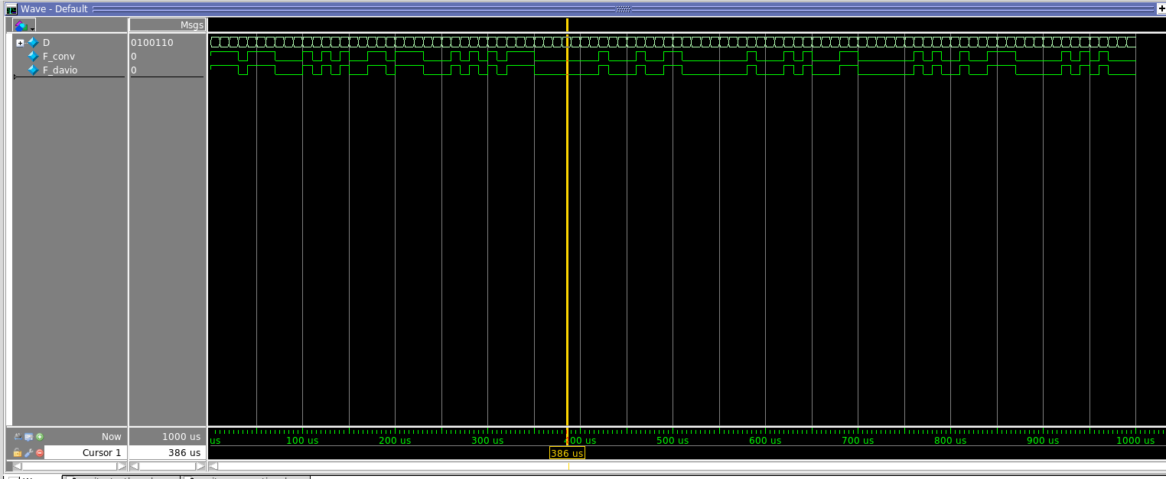

4.
Shannon-Davio Expansion:
Normal: 7 LE’s
Performance(aggressive): 7 LE’s
Power: 7 LE’s
Area: 7 LE’s

Conventional:
Normal: 8 LE’s
Performance(aggressive): 8 LE’s
Power: 8 LE’s
Area: 8 LE’s

it appears there was a slight improvement in the davio expansion design, however the Quartus compiler is already too advanced and the different compiler settings yielded no differences within the two designs.

